Anthony Berrios

CSC_345

Professor Jongwook Kim

10/8/20

Assignment #2

On my honor, Anthony Berrios, this assignment is my own work and I have not shared my solution with anyone.

1. Show a parse tree and a leftmost derivation for the following statement.

A = B * (C * (A + B))

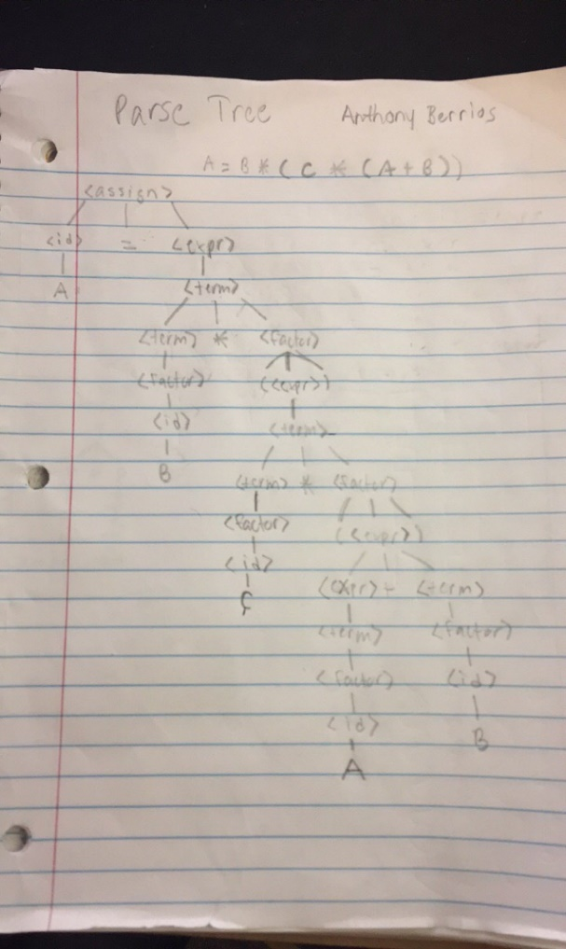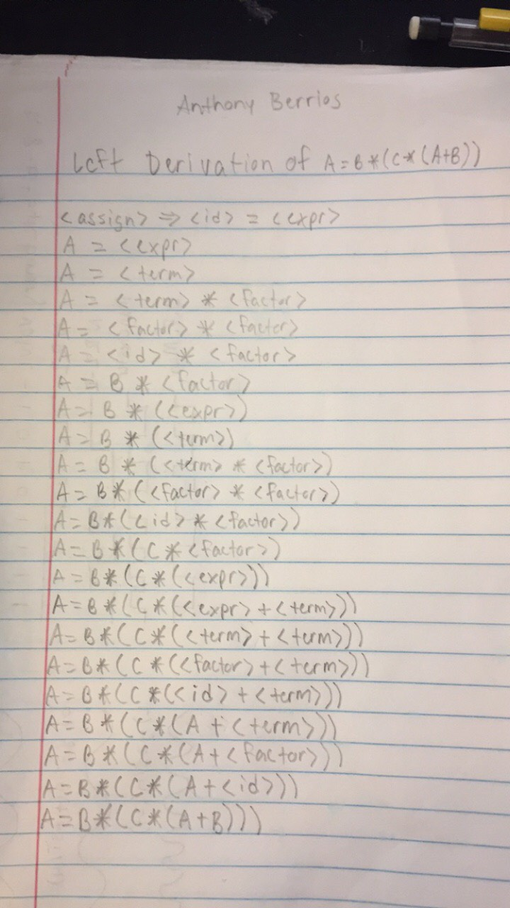

(2) (10 points) Show a trace of the recursive descent parser given in lecture slides “(4) Syntax.pdf” for the strings below.

**(i) (5 points) a + b * c**

Next token is: 11, Next lexeme is a

Enter <expr>

Enter <term>

Enter <factor>

Next token is: 21, Next lexeme is +

Exit <factor>

Exit <term>

Next token is: 11, Next lexeme is b

Enter <term>

Enter <factor>

Next token is: 23, Next lexeme is *

Exit <factor>

Next token is: 11, Next lexeme is c

Enter <factor>

Next token is: -1, Next lexeme is EOF

Exit <factor>

Exit <term>

Exit <expr>

**(ii) (5 points) a * (b + c)**

Next token is: 11, Next lexeme is a

Enter <expr>

Enter <term>

Enter <factor>

Next token is: 23, Next lexeme is *

Exit <factor>

Next token is: 25, Next lexeme is (

Enter <factor>

Next token is: 11, Next lexeme is b

Enter <expr>

Enter <term>

Enter <factor>

Next token is: 21, Next lexeme is +

Exit <factor>

Exit <term>

Next token is: 11, Next lexeme is c

Enter <term>

Enter <factor>

Next token is: 26, Next lexeme is )

Exit <factor>

Exit <term>

Exit <expr>

Next token is: -1, Next lexeme is EOF

Exit <factor>

Exit <term>

Exit <expr>